Exam questions
1. If the default gateway is misconfigured what is the consequences for communication:
The host can communicate with other hosts on the local networks but is unable to communicate with hosts on the remote network.

2.Function and features of layers 2 switches?
Functions:
- Learning Addresses:
(Learn the MAC addresses of each incoming frames on a port to allow it to be extremely efficient in handling future traffic)

- Forward/Filter decisions:
(It matches the MAC address on an incoming frame with the MAC address on the switches Filter table)

- Loop Avoidance:
(Help prevent network loops that can occur when multiple connections between switches are created for redundancy purposes.)
Features:
- Data Forwarding:
(Forward data packets within the same local network based on MAC addresses)

- MAC Address Learning:
(Learn the MAC addresses of devices connected to their ports, enabling them to forward data packets` to the intended destinations.)

- Filtering:
(Switches forward frames only through ports where the MAC address of the destination device is known, enhancing network efficiency and security.)

3. Compare OSI and TCP/IP Model?
OSI Model
Layers: The OSI model consists of 7 layers: Physical, Data Link, Network, Transport, Session, Presentation, and Application.
Approach: Follows a vertical approach.
Reliability: Less reliable compared to TCP/IP.
Advantages: Offers flexibility and works independently.
Disadvantages: Setting up the model can be challenging, fitting new protocols can be difficult.

TCP/IP Model
Layers: The TCP/IP model comprises 4 layers: Physical, Network, Transport, and Application.
Approach: Follows a horizontal approach.
Reliability: More reliable than the OSI model.
Advantages: Supports many routing protocols, is highly scalable, and lightweight.
Disadvantages: Setting up can be a bit difficult, packet delivery is not guaranteed by the transport layer, and vulnerable to attacks.

4. Network layer function?
(directing data…./ provide end devices with unique identifier)
Functions:
- Network Addressing:
The network layer adds source and destination addresses to the data packets in the header to identify where the data is being shared on the network.
- Inter-Networking:
It handles network connections between multiple devices in the network.
- Packet Routing:
selecting the most suitable route from available network channels.
- Packet Handling:
This function involves converting data received from upper layers of the OSI model into data packets for transmission over the communication channel.

5. Protocol’s operating in application layer?
- HTTP( Facilitates message communications. ) 80.
- FTP ( Handles file transfer activities) 21.
- TFTP (used for file transfer) 69.
- IMAP (used for retrieving emails from a mail server to a client device.) 143.
- DNS. (Resolve domain name into IP addresses) 53

6. Transport layer function?
- Tracking individual conversations:
(Individual conversations between applications on different hosts.)

- Segmenting data and reassembling segments:
(Breaking down large data streams into smaller segments for efficient transmission over the network.)

- Adds header information:
(Is crucial for error detection, flow control, and ensuring reliable data transmission.)

- Uses segmentation and multiplexing:
(Allows multiple applications to share a single network connection.)

7.Protocols operating on transport layer:
- TSP:
- ensures reliable data transmission.
- Provide error detection, and flow control.

- UDP :
- connectionless protocol
- Faster transmission, suitable for real-time applications.

8. Function of DNS:
- Resolve the domain name such as ciso.com into IP addresses.

9. The loopback address for ipv4:
- The loopback address for IPv4 is a special address used for internal testing purposes.
- 127.0.0.0 /8 (127.0.0.1 to 127.255.255.254)
- Commonly identified as only 127.0.0.1
- Used on a host to test if TCP/IP is operational.

10.Class A to E for ipv4:
Class A (0.0.0.0/8 to 127.0.0.0/8)
- (used for large networks)
- (the first octet identifies the network, and the remaining bits identify hosts)
Class B (128.0.0.0 /16 – 191.255.0.0 /16)
- (used for medium-sized networks)
- (The first 16 bits identify the network, and the remaining 16 bits identify hosts.)
Class C (192.0.0.0 /24 – 223.255.255.0 /24)
- (Used for small size networks)
- (The first 24 bits identify the network, and the remaining 8 bits identify hosts.)
Class D (224.0.0.0 to 239.0.0.0)
- (They are reserved for multicast applications)
Class E (240.0.0.0 – 255.0.0.0)
- (Reserved for experimental purposes)

11. Ipv6 multicast:
- Multicast is used to send a single IPv6 packet to multiple destinations.
In IPv6, how are multicast addresses represented.
- With the prefix FF02::

12.Link local unicast addresses:
- It can be configured manually using the ipv6 address.
- Configuring it manually lets you create an address that is recognizable and easier to remember.

Configuration:
- R1(config)# interface gigabitethernet 0/0/0
- R1(config-if)# ipv6 address fe80::1:1 link-local
- R1(config-if)# no shutdown
- R1(config-if)# exit

Link-local Unicast:
- used for communication within the same network segment.

13.The purpose of using Ipv6:
- IPv6 has a much larger 128-bit address space.
- IPv6 also included fixes for IPv4 limitations and other enhancements.
- IPv6 provides increased efficiency and security.
- With an increasing internet population, IPv6 is more suitable to use.

14. Star Topology functions and features:
Star topology Feature:
- Centralized management
- Scalability
- Reliability
- Easy to expansion
- Security
- Fault tolerance
Star topology Functions:
- Data transmission
- Communications
- Switch usage (a switch can replace hub star topology )

15. What cables are used ethernet network:
Ethernet Straight-through:
- used to connect a host to a network device.

Ethernet Crossover:
- Is used to connect a Host-to-Host, Switch-to-Switch, Router-to-Router.

Rollover:
- is used to connect host serial port to router or switch console port using an adapter.

16. Wired ethernet network collision how its handled:
- handled through a mechanism called CMSA/CD

CSMA/CD collision detection process:
- Devices transmitting simultaneously will result in a signal collision on the shared media.
- Devices detect the collision.
- Devices wait for a random period of time and retransmit data.

17. Encapsulation process of OSI model:
PDU is the protocol data unit.
- When the data that need to be transmitted arrives to the transport layer it will be called a segment
- Transport layer will add a TCP header.
- When it gets to the network layer is called a packet.
- Network layer will add an IP header.
- When it gets to the data link layer it will be called a frame.
- Datalink layer will add Ethernet header.
- Until it is a bit stream.

18. Email protocols:
- SMTP (Simple Mail Transfer Protocol): (port 25)
Used for sending emails from a client to a server or between servers.
- IMAP (Internet Message Access Protocol): (port143)
allow users to access their mailboxes, read emails, and manage messages on a server.
- POP (Post Office Protocol): (port 110)
Messages are kept in the mail server until they are manually deleted by the email client.

19. Simple network management protocol SNMP:
- is an application layer protocol used for the management and monitoring of network-connected devices.

20. Network security:
- Firewall:
Filtering and controlling network traffic based on predetermined security rules.
- How does the service password-encryption command enhance password security on Cisco routers and switches?
It encrypts passwords that are stored in router or switch configuration files.

- VPN:
Virtual private network used to secure network.
A tunneling protocol….

- What is IDS:
Intrusion detecting system.
What is the purpose of IDS in network security?
- Detecting and alerting on suspicious activities or security breaches.
21. Wireless LAN security?
- WPA2-PSK:
is a network security type where all users share a single password for access.
- EAP:
higher security control.
- WPA:
is a wireless security protocol.

22.Why do you set IP address for a switch?
Allows remote management to the switch.

23. What are the advantages of using UTP?
- does not fill up wiring ducts.
- is easy to install.
- less expensive
- Reduced electromagnetic interference.

24. Running config, startup config:
The network administrator wants to save the router configuration so that it will be used automatically the next time that the router reboots. What command should be issued?
Running config, startup config

25. Router #sh ip arp:
What command can be used to display ARP table on a cisco router?
- Show ip arp

26. Routing table:
What type of route is indicated by code C in an IPv4 routing table on cisco router?
- Directly connected route.

27. using open standard protocol :
What is an advantage using protocol….open standard?
It encourages competition.
28. use of no shutdown in cisco:
What command is used to bring up a disabled router interface?
Router(config-if)# no shutdown

29. What is the purpose of DHCP?
- Assign IP addresses to end devices.
- And has a destination port number of 67.

30. Address resolution protocol (ARP):
What are the two features of ARP:
- If the host is ready to send a packet to a local destination device and it has it IP address but not it MAC address, it will generate an ARP broadcast.
- If a device receives an ARP request, it responds with an ARP reply.

What are the two problems that caused for large number of ARP requests?
- The ARP request is sent as broadcast.
- All ARP requests messages must be processed.

31. Function of Mac sublayer:
provides control for accessing the transmission medium. It is responsible for moving data packets from one network interface card (NIC) to another, across a shared transmission medium.
- Accessing the media
- Data encapsulation

32. Three-way handshake process in the transport layer:
Before TCP transmits the data, it will use the three-way handshake to establish a connection.

- Step 1: the client will send an SYN segment to the server asking for synchronization.
(This message basically asks the server for connection)

- Step 2: The server will reply with SYN-ACK (Synchronization and acknowledgement)
(the server acknowledges the client’s connection request and ask client to open a connection too)

- Step 3: The client replies with ACK which means yes.
(A two-way connection is established between them)

Function :
- It establishes that the destination device is present on the network.
- It verifies that the destination device is active and accepts requests on destination port number.
- It informs the destination device that the source client wants to establish a communication.

33. Ethernet Field size:
Which Frame field is created by source node…...?
Frame check sequence field.

34. Router interfaces (serial, flash):

35. Transmission medium diagrams:
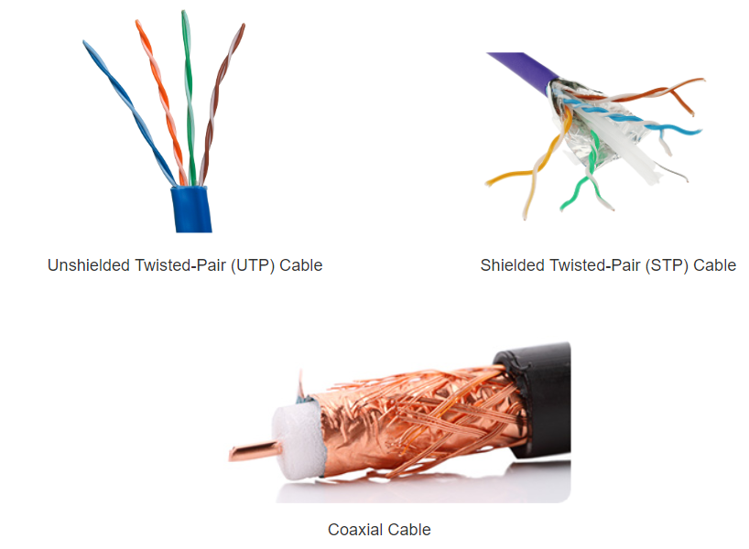

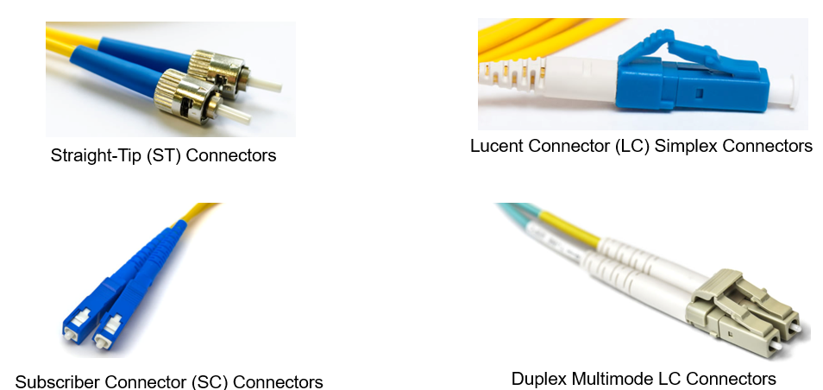
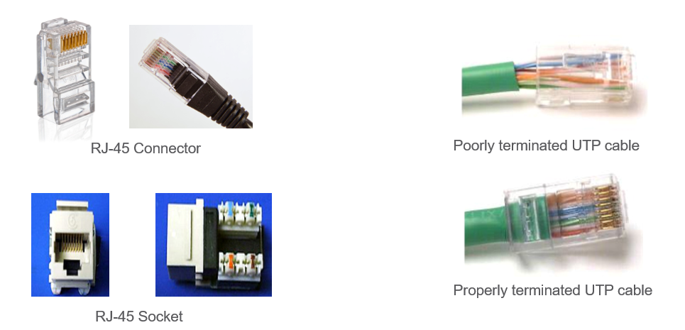
36.Google characteristics of port-based security using mac address:
Which security measure prevents unauthorized devices from connecting to a network based on their MAC address?
- Port security

37. How to calculate usable host address:
What are the total number of usable host addresses you can have /24 network?
- Subnet mask= /24
- 24 ones and followed by 8 zero because the total should be 32.
- 11111111.11111111.11111111.00000000
- The ones are the number of bits that identify a network.
- And zero is the number of bits that identify the host.
- We use the formula h=2^x-2
- The “h” is the number of usable host address, and the x is the number of “0” of the subnet mask.
- h=2^8-2
- h=254

38. default subnet mask for all classful addressing:
39. Translate private ipv4 address to public address:
40. Ipv6 standards (e.g. how many bits):
- IPv6 has 128 bits.
- They are expressed in colon hex notation (:)

41. show ip route
What is the command used to display IPv4 routing table of a router?
- show ip route

